|  |
| --- |
|  |
| 新概念 3 册 |
| Lesson43 Fully insured |



Book

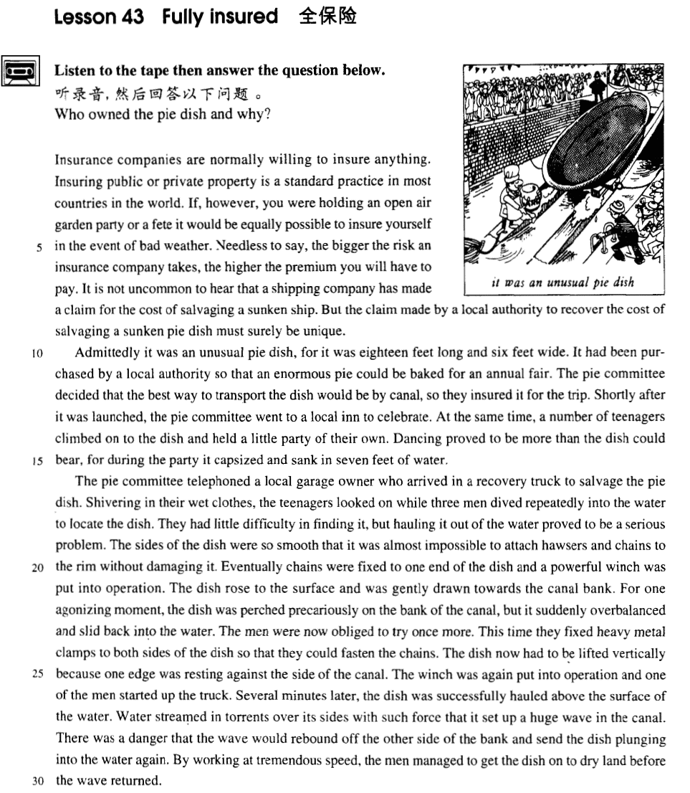

课文

Insurance companies are normally willing to insure anything.

保险公司一般说来愿意承保一切东西。

Insuring public or private property is a standard practice in most countries in the world.

承办公共财产或私人财产保险是世界上大部分国家的正常业务。

If, however, you were holding an open air garden party or a fete it would be equally possible to insure yourself in the event of bad weather.

如果你要举办一次露天游园会或盛宴，为避免碰上不好的天气而遭受损失也同样可以保险，

Needless to say, the bigger the risk an insurance company takes, the higher the premium you will have to pay.

不用说，保险公司承担风险越大，你付的保险费也就越高。

It is not uncommon to hear that a shipping company has made a claim for the cost of salvaging a sunken ship.

航运公司为打捞沉船而提出索赔，这是常有的事，

But the claim made by a local authority to recover the cost of salvaging a sunken pie dish must surely be unique.

但某地当局为打捞一只焙制馅饼的盘子提出索赔，倒是件新鲜的事儿。

Admittedly it was an unusual pie dish, for it was 18 feet long and 6 feet wide.

这个馅饼盘子确实少见，有18英尺长，6英尺宽。

It had been purchased by a local authority so that an enormous pie could be baked for an annual fair.

某地方当局买下它用来焙制一个巨大的馅饼为一年一度交易会助兴。

The pie committee decided that the best way to transport the dish would be by canal so they insured it for the trip.

馅饼委员会确认运输这只盘子的最佳方案是通过运河水运。于是，他们对这只盘子的运输安全投了保。

Shortly after it was launched, the pie committee went to a local inn to celebrate.

盘子下水后不久，馅饼委员会成员们来到当地一家小酒店庆贺。

At the same time, a number of teenagers climbed on to the dish and held a little party of their own.

就在这个时候，许多十几岁的孩子爬盘子举行他们自己的集会。

Dancing proved to be more than the dish could bear, for during the party it capsized and sank in seven feet of water.

他们跳起了舞，盘子难以承受。舞会进行过程中，盘子倾覆，沉入了7英尺深的水中。

The pie committee telephoned a local garage owner who arrived in a recovery truck to salvage the pie dish.

馅饼委员会给当地汽车修理库老板打电话，他闻讯后开着一辆急修车前来打捞盘子。

Shivering in their wet clothes, the teenagers looked on while three men dived repeatedly into the water to locate the dish.

那些孩子们穿着湿衣服哆嗦，看着3个工人轮潜入水中以确定盘子的位置。

They had little difficulty in finding it, but hauling it out of the water proved to be a serious problem.

他们没费多大事儿就找到了盘子。可是把盘子捞出却是一个很大的难题。

The sides of the dish were so smooth that it was almost impossible to attach hawsers and chains to the rim without damaging it.

盘子四边十分光滑，要在盘边拴上绳索或链条而同时又不损坏它是很难办到的。

Eventually chains were fixed to one end of the dish and a powerful winch was put into operation.

不过，他们终于将链条固定在盘子的一端，一台大功率的绞车开动起来。

The dish rose to the surface and was gently drawn towards the canal bank.

盘子慢慢浮出水面，被轻轻地拽向运河岸边。

For one agonizing moment, the dish was perched precariously on the bank of the canal, but it suddenly overbalanced and slid back into the water.

在令人忐忑不安的瞬间，盘子晃晃悠悠地上了岸，但它突然失去了平衡，又跌回水中。

The men were now obliged to try once more.

工人们只得再来一次。

This time they fixed heavy metal clamps to both sides of the dish so that they could fasten the chains.

这次，他们用沉重的金属夹子把盘子夹住，以便往盘子上安装铁链。

The dish now had to be lifted vertically because one edge was resting against the side of the canal.

这次，盘子必须垂直吊出水面，因为盘子的一边紧靠着运河河岸。

The winch was again put into operation and one of the men started up the truck.

绞盘机再次启动，一位工人发动了急修车的引擎。

Several minutes later, the dish was successfully hauled above the surface of the water.

几分钟后，盘子被成功地拽出了水面。

Water streamed in torrents over its sides with such force that it set up a huge wave in the canal.

波浪从盘子两侧急涌而出，在运河里掀起一股大浪。

There was a danger that the wave would rebound off the other side of the bank and send the dish plunging into the water again.

但是当波浪从河对岸折回来时，就有再次把盘子拖进水里的危险。

By working at tremendous speed, the men managed to get the dish on to dry land before the wave returned.

工人们动作迅速，终于赶在那股大浪返回之前把盘子拽到了岸上。

词汇讲解

* **insure** [ɪn'ʃʊə(r)] v. 投保，为……上保险

**insure … against …** 为某人/某物上保险

* I have **insured** my house **against** fire / burglary.
* I have **insured** myself **against** illness.

**insure … for …** 为某人/某物上了多少钱的保险

* They’ve **insured** the painting **for** a million pounds.

**【扩展】**

**insure** (US) / **ensure** (UK) 确保、保证

= **make sure / certain**

* **insure** / **ensure** passenger safety
* One more goal will **ensure** / **ensure** victory.
* The role of the police is to **insure** / **ensure** (that) the law is obeyed.

**assure sb. of sth.** 让某人放心

**assure sb. (that) …**

* The dealer **assured me of** its quality.
* I **assure you (that)** I’ll be there on time.
* **recover** [rɪ'kʌvə(r)] v. 重新获得，找回，赚回，补偿；康复，恢复正常
* Four paintings stolen from the gallery have been **recovered**（找回）.
* We **recovered**（补偿） lost time by setting out early.
* But the claim made by a local authority to **recover** （补偿）the cost of salvaging a sunken pie dish must surely be unique.

**recover sth. from sth.** 从…找回了损失、补偿

* Two bodies **were recovered**（找回） **from** the wreckage.
* He was entitled to **recover**（补偿） **damages from** the defendants.
* After a few days of fever, she began to **recover**（康复）.

**recover from …** 从…中康复

* He's in hospital, **recovering from**（康复） a heart attack.
* Trade soon **recovered from** （康复） the effects of the war.

**【近义词组】**表达“**vt. 恢复了…**”：

**recover**

**restore**

**regain**

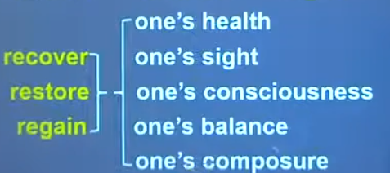

* **admittedly** [əd'mɪtɪdli] adv. 诚然，的确，确实

**admittedly**

英文解释：adv. used, especially at the beginning of a sentence, when you are accepting that sth is true **诚然，的确，确实**

* **Admittedly**, he didn't know that at the time.
* Admittedly it was an unusual pie dish, for it was 18 feet long and six feet wide.

**【扩展】**表达“**诚然…，但是…**”：（让步转折结构）

**Admittedly, ..., but ...**

**Granted, …, but …**

**It is true that ..., but ...**

* **Admittedly**, it was difficult, **but** it wasn't impossible.
* **Granted**, he doesn't look too bad for his age, **but** I don't fancy him.
* **It was true that** he had just bought a lamb, he explained, **but** his lamb was black.

“**诚然…，但是**（进阶结构）**…**”

* It is true that / Admittedly, / Granted**, but that is** not to say that ...
* It is true that / Admittedly, / Granted**, but it does not** follow that ...
* It is true that / Admittedly, / Granted**, but it does not** necessarily mean that ...
* It is true that / Admittedly, / Granted**, but there is no** guarantee that …
* 造句：确实很多大学生选择继续读研究生 (pursue their graduate studies)，但这并不意味着他们都想做学者。
* **Admittedly**, many college students choose to pursue their graduate studies, **but it does not** necessarily mean that they want to be scholars.
* **annual** ['ænjuəl] adj. 每年的，年度的
* **annual** **income** / **meeting** / **ring** 年收入/年会/年轮

**【同根词】**

**annually** adv. 一年一次地

* The jazz festival is held annually in July.

**【近义词】**

**yearly** adj. & adv. 每年的、一年一次的； 年度的；一年的

* **yearly** **income** / **interest** / **budget** （adj.）年收入/年息/年度预算
* The magazine is issued twice **yearly**.

**【扩展】**

**daily** adj. & adv. 每日的；日常的

* **daily** (=**everyday**) life
* The zoo is open **daily** (=**every day**).

**weekly** adj. & adv. 每周的

* a **weekly** magazine
* The group meets **weekly** (=**every week**).

**monthly** adj. & adv. 每月的；每月一次的

* a **monthly** salary of $850
* They meet **monthly** (=**every month**) to discuss progress.

**【扩展】adj.**

**biannual** 一年两度的

**biennial** 两年一次的

**triennial** 每三年一次的；每三年的

**centennial** n. 百年纪念 adj. 一百年的

**millennial** adj. 一千年的；千禧年的

**perennial** 长久的；持续的；反复出现的

* **perennial** happiness / youth

**【扩展】n.**

**decade** 十年，十年期（尤指一个年代）

**century** 100 年；百年

**millennium** 一千年，千年期（尤指公元纪年）

* **teenager** ['ti:neɪdʒə(r)] n. 13~19 岁的青少年

**teenager**

= **teen**

* a magazine aimed at **teenagers** / **teens** in one’s teens
* She was **in her teens** （在某人十几岁的时候）when she met him.

**teenage** adj. 十几岁的（指 13 至 19 岁）；青少年的

* a **teenage** boy
* my **teenage** daughter

**【总结】【复习】**表达“**年龄段的**”：

**youth** 青年时期（尤指成年以前）；青年男子；小伙子（略贬义）

* a gang of **youths**

**youngster** （老年人称呼晚辈）年轻人；少年；儿童

* You **youngsters** have got your whole life ahead of you.

**minor** （法律） 未成年人

* It is illegal to sell alcohol to a **minor**.

**adolescent** 青少年

* An **adolescent** between the ages of 13 and 19 is called a teenager.
* an **adolescent** boy

**juvenile** （法律）少年的；未成年的

* Most of the suspects were **juveniles** under the age of 17.
* **juvenile** delinquent
* **juvenile** delinquency
* **haul** [hɔ:l] v. （用绳子）用力拖拉
* Rescue workers attached the men to ropes before **hauling** them to safety.

**【近义词】**

**drag** （强调摩擦力、阻力大）拖，拉，拽，扯

* He **dragged** the heavy chest across the floor.
* The police **dragged** the soccer hooligan off the pitch.

**tow** （用绳索或链条）拖，拉，牵引，拽

* My car broke down and had to be **towed** to a garage.

**trail** （被）拖，拉

* She walked slowly along the path, her skirt **trailing** in the mud.

**tug**  （常为几次用力）拉，拖，拽

* We **tugged** it so hard that the rope broke.

**pull** / **draw** （通用）

* **agonizing** ['ægənaɪzɪŋ] adj. 令人痛苦的， 令人伤脑筋的
* an **agonizing** injury
* an **agonizing** choice / decision / dilemma

**agonized** （感到）十分痛苦的；很焦虑的

* an **agonized** expression / scream

**agonize about / over …** 对某事伤脑筋、拿不定主意

* For days I **agonized about** whether to accept his advice.

**agony** n. （精神或肉体的）极度痛苦

* He groaned in **agony**.
* **vertically** ['vɜ:tɪklɪ] adv. 垂直地
* the **vertically** challenged （委婉表达）侏儒
* the **horizontally** challenged （委婉表达）肥胖表达

**【扩展】**

**diagonally** adv. 对角地；斜对地

* The path goes **diagonally** across the field.

**vertical / perpendicular** 垂直的；成直角的

**horizontal** 水平的；与地面平行的；横的

**diagonal** 斜线的；对角线的

**curved** 呈弯曲状的；弧形的

**circuitous / tortuous** 迂回的；绕道的；曲折的

* The road is **tortuous**, but the prospects are bright.

课文讲解

# （第一段）

# Insurance companies are normally willing to insure anything.

知识点（1）

**insurance** 保险

* insurance company 保险公司
* insurance agent / broker 保险经纪人
* insurance policy 保单
* insurance premium 保险费
* medical care insurance 医疗保险
* endowment insurance 养老保险
* unemployment insurance 失业保险
* housing fund 住房公积金
* social insurance 社会保险
* personal insurance 个人保险
* commercial insurance 商业保险
* life insurance 人寿保险
* accident insurance 意外保险
* travel insurance 旅行保险
* fire insurance 火险
* car insurance 车险

知识点（2）

**normally** adv. **含义1.** usually 通常

* The journey **normally** takes about two hours.

**normally** adv. **含义2.** in a normal way 正常地

* Her heart is beating **normally**.

# Insuring public or private property is a standard practice in most countries in the world.

知识点（1）

**possessions** / **property [U]**  泛指“财产”

**property** / **real estate**  不动产

**belongings** / **things** 动产

知识点（2）

**practice** n. 习俗，惯例，习惯性的做法

* On the other hand, your stomach would turn at the idea of frying potatoes in animal fat—the normally accepted **practice** in many northern countries.

# If, however, you were holding an open air garden party or a fete it would be equally possible to insure yourself in the event of bad weather.

**语法分析:**

**If**, *however（插入语）*, you were（虚拟语气） holding an open air garden party or a fete（**if**... 条件状语从句；） *it（形式主语）* would be equally possible ***to*** *insure yourself in the event of bad weather（****to****... 真正主语）*.

知识点（1）

**open-air** = **outdoor** adj.户外的

* an **~** concert / swimming pool （形容词）露天的

**in the open air**（介词短语做状语） = **outdoors** = **out of doors** adv. 在户外

* The wedding was held **~**.

**indoor** adj. 室内的

**indoors** adv. 在室内

知识点（2）

**fete** n. 英文解释：[BrE] an outdoor event where there are competitions and things to eat and drink, usually organized to get money 游园会, 义卖会

知识点（3）

**in the event of …** 万一（某个不好的事情发生）

= **in case of …**

* The party will be held indoors **in the event of** / **in case of** rain.

**in any event** 无论如何

= **in any case**

= **come what may**

* **~** I shall go before Tuesday.

# Needless to say, the bigger the risk an insurance company takes, the higher the premium you will have to pay.

**语法分析:**

*Needless to say（状语）*, the bigger the risk an insurance company takes（the bigger… 定语从句）（比较状语从句）, the higher the premium you will have to pay（定语从句）.（the higher… 比较主句；**时态：主将从现**）

知识点（1） Lesson36

**needless to say** 不用说也知道

* **Needless to say**, the man's name was Hans Bussman and he really was Franz's long-lost brother.

知识点（2）Lesson9、43、55比较从句；复习、进阶

**语法**：“越…越…”比较

1.两个the 分别放在句首，前半句从句，后半句是主句，从前往后翻译

* The harder they worked(前半句从句，类似条件状语从句) the hungrier they became. （后半句是主句）
* The more he gets, the more he wants
* The harder you work, the greater progress you will（时态：主将从现） make.
* The more democracy spreads, the stronger *become*（倒装）the forces of peace.
* **如果谓语动词是be动词，这种句型可省略:**
* The younger the child *is*, the more *is / will be* the child’s need of sleep.
* The younger the child, the more the child’s need of sleep. （be动词省略）
* The higher the standard of living, the greater the amount of paper used. （be动词省略）
* The higher the standard of living *is*, the greater *is / will be*（倒装）the amount of paper used.
* **课文写法替换：**
* Needless to say, the bigger the risk an insurance company takes, the higher the premium you will have to pay.
* Needless to say, the bigger the risk an insurance company takes *is,* the higher *will be*（倒装）the premium you will have to pay.

2.第一句the加比较级放在句中，第二句the加比较级放在句首，只能先翻译后半句，再翻译前半句

* They became **(the) hungrier** （前半句是主句）**the harder** they worked.（后半句是从句）

# It is not uncommon to hear that a shipping company has made a claim for the cost of salvaging a sunken ship.

**语法分析:**

It（形式主语） is not uncommon *to hear that a shipping company has made a claim for the cost of salvaging a sunken ship（目的状语）*. （*to*... 真正主语）

知识点（1）

**it is not uncommon (for sb.) to do** 对某人来说做某事一点也不新鲜

* **It is not uncommon for** students **to have** bank loans.
* **It is not uncommon for** Chinese **to be** given names of popular slogans.

知识点（2）

**claim** n. 索赔要求

* Fortunately for them, the Bank of England has a team called Mutilated Ladies which deals with **claims** from people who fed their money to a machine or to their dog.

**make / file a claim for …** 对…提出索赔要求

**drop / waive a claim for …** 放弃…索赔要求

**allow / uphold a claim for …** 支持…索赔要求

**dismiss / reject a claim for …** 驳回…索赔要求

# But the claim made by a local authority to recover the cost of salvaging a sunken pie dish must surely be unique.

**语法分析:**

But the claim made by a local authority *to recover the cost of salvaging a sunken pie dish* （made… 后置定语，修饰claim）（to recover…后置定语，修饰claim）must surely be unique.

知识点（1）

**authority** 政府当局

* Fearing the **authorities**, Eric remained in hiding after the war as well.
* It is all too easy to blame the railway **authorities** when something does go wrong.

# （第二段）

# Admittedly it was an unusual pie dish, for it was 18 feet long and 6 feet wide.

# It had been purchased by a local authority so that an enormous pie could be baked for an annual fair.

**语法分析:**

It had been purchased by a local authority so that an enormous pie could be baked for an annual fair. （so that… 目的状语从句）

知识点（1）

**语法：so (that) 作连词时一般来说有两种用法**：

1. 引导结果状语从句，译为“所以”，从句谓语动词中一般没有情态动词。

2. 引导目的状语从句，译为“以便”= in order that …，从句谓语动词中多出现情态动词 can, could, may, might, should, would 等。

* We paid him immediately, **so (that)** he left contented. （所以）
* We paid him immediately, **so (that)** he would leave contented. （以便）
* The pie committee decided that the best way to transport the dish would be by canal, **so**（所以） they insured it for the trip.
* In the new country he became absorbed in making a new life for the two of us, **so that** （所以）he gradually ceased to grieve.
* It had been purchased by a local authority **so that** （以便）an enormous pie **could** be baked for an annual fair.
* This time they fixed heavy metal clamps to both sides of the dish **so that** （以便）they **could** fasten the chains.

知识点（2） Lesson26

**bake** v. to cook food in an oven without extra fat or liquid 焙烤

* During a radio programme, a company of biscuit manufacturers once asked listeners to **bake** biscuits and send them to their factory.

知识点（3）

**fair** **英文解释：**n. a large public event where goods are bought and sold, usually from tables which have been specially arranged for the event, and where there is often entertainment 大型集市，庙会

# The pie committee decided that the best way to transport the dish would be by canal so they insured it for the trip.

知识点（1）

**decide** 不一定译为“决定”，而常常译为“**（在考虑之后）确定，断定，认为**”，尤其是其后加 that 引导的宾语从句时。

* From then on, Harry **decided**（确定，断定，认为） that this little game he had invented might prove to be expensive.
* I **decided**（确定，断定，认为） that I must have taken a wrong turning somewhere.
* Her first impulse was to go round all the rooms looking for the thieves, but then she **decided**（确定，断定，认为） that at her age it might be more prudent to have someone with her, so she went to fetch the porter from his basement.

# Shortly after it was launched, the pie committee went to a local inn to celebrate.

知识点（1）

**shortly before / after …** 在…**之前/之后**不久

* The accident happened **shortly before**（介词） midday.
* I saw him **shortly before**（连词） he died.
* Police arrived at the scene **shortly after**（介词） midnight.
* **Shortly after**（连词） it was launched, the pie committee went to a local inn to celebrate.

**Shortly afterwards** （副词短语）不久之后

* **Shortly afterwards**, four more policemen arrived and remonstrated with the workmen.

**long before / after …**在…**之前/之后**很久

* He was known to us all as Dickie and his eccentricity had become legendary **long before**（连词） he died.
* She was sentimentally attached to this house, for even though it was far too big for her needs, she persisted in living there **long after**（介词） her husband's death.

知识点（2）

**launch** v. to put a boat or ship into the water 使船下水

* The lifeboat was **launched** immediately to rescue the four men.

知识点（3）

**inn** n. a small hotel or pub, especially an old one in the countryside（乡下的）酒馆，客栈

# At the same time, a number of teenagers climbed on to the dish and held a little party of their own.

# Dancing proved to be more than the dish could bear, for during the party it capsized and sank in seven feet of water.

知识点（1）

**be more than … can / could...** 是…不能承受的

* When my old friend Brian urged me to accept a cigarette, it **was more than I could** bear.
* The pain **is more than I can** bear.
* The story **is more than I can** believe.
* The beauty of the West Lake **is more than** words **can** describe.
* The weather turned out to be very good, which **was more than we could** expect.

# （第三段）

# The pie committee telephoned a local garage owner who arrived in a recovery truck to salvage the pie dish.

知识点（1）

**语法复习：**定语从句充当并列句

* The pie committee telephoned a local garage owner **and the owner** arrived in a recovery truck to salvage the pie dish.

知识点（2）

**a recovery vehicle / truck** 维修拖车

英文解释：one for taking broken-down cars, etc. to a garage 维修拖车（把毁坏的汽车等拉回修理厂的车）

# Shivering in their wet clothes, the teenagers looked on while three men dived repeatedly into the water to locate the dish.

**语法分析:**

Shivering in their wet clothes（非谓语动词作伴随状语), the teenagers looked on *while three men dived repeatedly into the water to locate the dish（to... 目的状语从句）*. （while...时间状语从句）

知识点（1）

**shiver**（只能指人） / **tremble** 发抖

* She **shivered** at the thought of going into the dark house alone.
* We were **trembling** with excitement.
* The bridge **trembled** as the train sped across it.
* **Shivering** in their wet clothes, the teenagers looked on while three men dived repeatedly into the water to locate the dish.
* Suddenly, there was a slight **trembling** sound from below, and the captain went down to see what had happened.
* By this time her legs were beginning to **tremble**, so she sat down and accepted a cup of very strong tea, while he telephoned the police.

知识点（2） Lesson22

**look on** 旁观（看热闹）

* The gaoler **looked on** eagerly, anxious to see if his fellow-actor had at last learnt his lines.

**onlooker** 旁观者

**look on … as** … 把…看作…

* We **look on** her **as** a daughter.

知识点（3） Lesson35

**locate** v.确定位置

* They **located** the right chimney by tapping at the walls and listening for the man's cries.

# They had little difficulty in finding it, but hauling it out of the water proved to be a serious problem.

知识点（1）

**have difficulty (in) doing sth.**  做某事很困难

= **have trouble (in) doing sth.**

= **have a hard time doing sth.**

* She **had a hard time writing** the dear John letter（绝交信）.

**have a good time doing sth.** 做某事开心、轻松

# The sides of the dish were so smooth that it was almost impossible to attach hawsers and chains to the rim without damaging it.

**语法分析:**

The sides of the dish were so smooth **that** it（形式主语） was almost impossible *to（真正主语） attach hawsers and chains to （真正主语）the rim without damaging it*. （**that**... 引导结果状语）

知识点（1）

**hawser** n.（船上的）粗缆绳

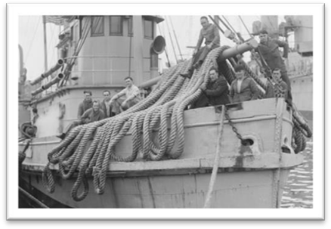

# Eventually chains were fixed to one end of the dish and a powerful winch was put into operation.

知识点（1）

**fix sth. to / on sth.** 把…固定到…

* The shelves should be **fixed to** the wall **with** screws.

知识点（2）

**winch** n. 绞车，卷扬机

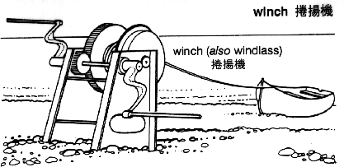

知识点（3）

**put / bring sth. into operation** 英文解释：to make sth start working 开动，实施，使生效

* It's time to **put our plan into operation**.
* New legislation will be **brought into operation** in January.

# The dish rose to the surface and was gently drawn towards the canal bank.

知识点（1） Lesson34

**gently** adv. 英文解释：carefully, without a lot of force or sudden change in movement 小心翼翼地

* Frank **gently** lifted the crockery out of the box and suddenly noticed a miniature painting at the bottom of the packing case.

# For one agonizing moment, the dish was perched precariously on the bank of the canal, but it suddenly overbalanced and slid back into the water.

知识点（1）

**moment** n. 1. a particular point in time 时间点，和介词at搭配

* Just **at** that **moment** there was a knock on the door.

**moment** n. 2. a very short period of time 一小段时间，可以和其他介词搭配

* I'll come back to that point **in a moment**.
* It was quiet **for a moment**, then Rae spoke.
* 'I don't understand,' said Lucy **after a moment**.

知识点（2）

**perch** 栖息；停留

**be perched on …** [处在某物的上面](gdlookup://localhost/%E5%A4%84%E5%9C%A8%E6%9F%90%E7%89%A9%E7%9A%84%E4%B8%8A%E9%9D%A2)

* The path led to a tiny village (which was) **perched on** the steep sides of a mountain.

知识点（3）

**precarious** 不稳的；不确定的；不保险的；危险的

* a **precarious** future
* He is in **precarious** health.

**precariously** adv. 不安全地；不牢靠地

* They lived **precariously** on the income from a few small investments.

知识点（4）

**overbalance** v. 失去平衡

# The men were now obliged to try once more.

知识点（1）Lesson1

**be / feel obliged to do sth.** （因为责任、道义）感到不得不做某事

* However, as the evidence began to accumulate, experts from the Zoo **felt obliged to investigate**, …
* He had **been obliged to join** the army during the Second World War.

# This time they fixed heavy metal clamps to both sides of the dish so that they could fasten the chains.

知识点（1）

**clamp** n. device for holding things tightly together, usu by means of a screw 夹具，夹钳

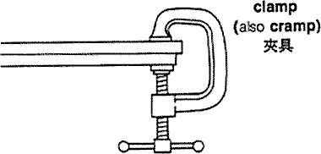 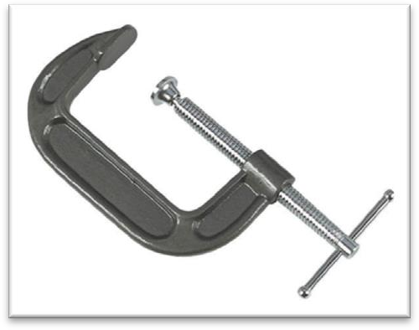

# The dish now had to be lifted vertically because one edge was resting against the side of the canal.

知识点（1）Lesson3

**rest (sth.) on / against sth.** 搭在…的东西上

* She stood three feet high and her hands **rested on** her hips.

# The winch was again put into operation and one of the men started up the truck.

知识点（1）

**start (sth.⇔) up** 发动（汽车或马达…）

英文解释：if an engine, car etc. starts up, or you start it up, it begins working

* The driver got back into the car and **started up**.
* Rory **started up** the engine and got the vehicle moving.

# Several minutes later, the dish was successfully hauled above the surface of the water.

# Water streamed in torrents over its sides with such force that it set up a huge wave in the canal.

**语法分析:**

Water streamed in torrents over its sides *with such force* ***that*** *it set up a huge wave in the canal*. （**that**... 引导结果状语）

知识点（1）

**torrent** n. 洪流

**in torrents** 倾盆大雨地

* The rain came down **in torrents**.

**【扩展】**表达“水流”：

**current** 水流

**stream**  流；（液）流；（气）流

**trickle** 细流；涓流

* The **trickle** became **a stream**; the **stream** has now become **a torrent**.

知识点（2） 复习

**such … that …** 如此…以至于…

* He wanted to buy a £300 watch for his wife, but he was in **such** *a bedraggled condition* **that** an assistant refused to serve him.

知识点（3） Lesson33

**set up** 造成，导致

* It is as if a single unimportant event **set up** a chain of reactions.

# There was a danger that the wave would rebound off the other side of the bank and send the dish plunging into the water again.

**语法分析:**

There was a danger **that** the wave would rebound off the other side of the bank and send the dish *plunging into the water again（分词短语）*. （**that**... 同位语从句）

知识点（1）Lesson25

**there is / was a danger that …** 有这样一种危险

* This greatly reduced the speed of the ship, for **there was a danger that** if she travelled too quickly, this rudder would be torn away as well.

知识点（2）

**【总结】【复习】“there be 型的无灵主语”：**

**there is always hope that …** 总是会有…的希望

**there is no denying that ...** 不可否认的是…

**there is no doubt / question that ...**  毫无疑问的是…

**there is every likelihood that ...** 很有可能…

**there is little likelihood that ...** 不大可能

**there is no shortage of ...** 有的是…

**there is an element of truth in ...** 有点道理…

**there is a good deal of truth in ...**  很有道理…

知识点（3）

**rebound from / off …** 从……反弹回来

* The ball **rebounded from / off** the goalpost and Owen headed it in.

知识点（4）

**send … doing** 使…突然移动

* A fire in the casino **sent** people **fleeing** for safety.
* A careless step **sent** rocks **tumbling** down on the climbers below.

# By working at tremendous speed, the men managed to get the dish on to dry land before the wave returned.

**语法分析:**

By working at tremendous speed（方式状语）, the men managed to get the dish on to dry land *before the wave returned（时间状语从句）*.

知识点（1）

**dry land** n. land rather than water （与河或海相对应的）陆地

* After three weeks at sea we were glad to be back on **dry land** again.
* She stands on **dry land** and is visited by thousands of people each year.